Biz-Light
Decision Support and Automation Dashboard for Micro-Businesses
Developed By:
Amna Aslam
Shahzadi Rania
Supervised By:
Ms. Tehmina Mehboob
Department of Software Engineering
Faculty of Computing
International Islamic University, Islamabad
2026

Final Approval
It is certified that this project report titled "Biz-Light" has been examined and approved as a partial fulfillment of the requirements for the degree of BS Software Engineering.

External Examiner
Signature: _____________________________

Internal Examiner
Signature: _____________________________

Supervisor
Signature: _____________________________

Declaration
We declare that this project titled "Biz-Light" is our original work and has not been submitted previously for any academic degree. All sources used have been properly cited.

Amna Aslam

Shahzadi Rania

Dedication
We dedicate this project to our beloved parents, whose unconditional love and endless sacrifices have made every milestone possible. To our respected supervisor, Ms. Tehmina Mehboob, whose patient guidance and scholarly insight shaped this work from its earliest stages. To our teachers and mentors at the Department of Software Engineering, International Islamic University, Islamabad, whose knowledge and dedication inspire us daily. And to every micro-entrepreneur striving to build a better future through determination and hard work — this system was built with you in mind.

Dissertation
A dissertation submitted to the Department of Software Engineering, Faculty of Computing, International Islamic University, Islamabad, as a partial fulfillment of the requirements for the award of the degree of Bachelors in Software Engineering.

Acknowledgement
All praise is due to Almighty Allah, the Most Gracious and Most Merciful, who bestowed upon us the knowledge, patience, and strength to undertake and complete this Final Year Project. Without His blessings, none of this would have been possible.
We would like to express our deepest and most sincere gratitude to our supervisor, Ms. Tehmina Mehboob, for her invaluable guidance, continuous encouragement, and unwavering support throughout the entire development of this project. Her expertise and constructive feedback greatly enhanced the quality and direction of our work.
We are profoundly grateful to the faculty members of the Department of Software Engineering, Faculty of Computing, International Islamic University, Islamabad, for sharing their knowledge and for the academic environment that made this project possible.
We also wish to thank our parents and families for their constant prayers, emotional support, and sacrifices that enabled us to pursue this academic journey. Their love and encouragement have been our greatest source of motivation.
Finally, we extend our appreciation to all the micro-business owners who participated in the user acceptance testing phase of this project. Their practical feedback was instrumental in shaping a system that is truly relevant to real-world business needs.
Amna Aslam
Shahzadi Rania

Project in Brief

Project Title: | Biz-Light: Decision Support and Automation Dashboard for Micro-Businesses
Objective: | To develop a unified web-based decision support and automation dashboard for micro and home-based businesses, enabling automated KPI computation, rule-based alert generation, and AI-assisted business insight delivery.
Undertaken By: | Amna Aslam  Shahzadi Rania
Supervised By: | Ms. Tehmina Mehboob, Department of Software Engineering, IIU Islamabad
Date Started: | September, 2025
Date Completed: | May, 2026
Tools Used: | Django 4.1, Python 3.10, MongoDB Atlas, Djongo ORM, Tailwind CSS, Chart.js, Groq LLM API, Vercel Serverless, Postman, Visual Studio Code, fpdf2, PyMongo
System Used: | Windows 11 / Ubuntu 22.04 LTS; Google Chrome 124; Mozilla Firefox 125; MongoDB Atlas Free Tier M0 (Cloud)

Abstract
Biz-Light is a web-based Decision Support and Automation Dashboard designed specifically for micro and home-based businesses operating through social media marketplaces and small e-commerce platforms. The system addresses a critical operational gap where micro-entrepreneurs, who lack access to enterprise-grade business intelligence tools, are forced to manage sales, inventory, and expenses through fragmented manual methods such as spreadsheets and notebooks. This disconnected approach prevents the systematic calculation of key performance indicators and results in reactive rather than data-driven decision-making.
The proposed system integrates sales tracking, inventory management, and expense monitoring into a unified platform, implementing a structured KPI computation engine that automatically calculates Revenue Growth Rate (RGR), Inventory Turnover Ratio (ITR), Expense Ratio (ER), Stock Coverage Period (SCP), and a composite Business Health Score (BHS). A deterministic rule-based evaluation engine monitors these KPIs against configurable thresholds to automatically generate operational alerts, including low-stock warnings, expense spike notifications, and sales decline indicators.
Biz-Light is built using the Django web framework with a MongoDB Atlas cloud database and deployed on Vercel as a serverless application. The system incorporates an AI explanation layer powered by the Groq LLM API, which transforms structured rule-based outputs into natural language business summaries comprehensible to non-technical business owners. Unlike black-box AI systems, the decision logic remains fully deterministic and transparent, with AI serving only as an explanability interface. The platform additionally supports integration with external e-commerce platforms including Shopify and WooCommerce via REST API synchronization. Evaluation through structured testing demonstrates that the system accurately computes KPIs, reliably triggers rule-based alerts, and significantly reduces manual analytical workload for micro-business operators.

Table of Contents
1.1 Introduction of the Project 10
1.2 Background of the Study 10
1.3 Problem Statement 11
1.4 Objectives of the Project 11
1.5 Scope of the Project 12
1.5.1 In-Scope Features 12
1.5.2 Out-of-Scope Features 13
1.5.3 Major System Modules 13
1.6 Overview of Existing Systems 13
1.6.1 E-Commerce Analytics Tools 13
1.6.2 Inventory Management Systems 13
1.6.3 Accounting Software 13
1.6.4 Business Intelligence Platforms 14
2.1 Introduction 16
2.2 Decision Support Systems 16
2.3 Key Performance Indicators 16
2.3.1 Revenue Growth Rate (RGR) 16
2.3.2 Inventory Turnover Ratio (ITR) 17
2.3.3 Expense Ratio (ER) 17
2.3.4 Stock Coverage Period (SCP) 17
2.4 Business Rule Engines 17
2.5 Business Health Scoring Model 18
2.6 Review of Similar Systems 18
2.6.1 Shopify Analytics 18
2.6.2 WooCommerce Reports 18
2.6.3 QuickBooks 18
2.6.4 Enterprise BI Tools 19
2.7 Limitations of Existing Solutions 19
2.7.1 Fragmented Data Integration 19
2.7.2 Lack of Rule-Based Decision Support 19
2.7.3 Absence of Composite Business Health Scoring 19
2.7.4 Limited Explainability of Insights 20
2.7.5 Technical Complexity and Cost Barriers 20
2.7.6 Finance-Centric Rather Than Performance-Centric Focus 20
2.7.7 Lack of Micro-Business Customization 20
2.8 Conceptual Framework of Biz-Light 20
2.8.1 Data Acquisition Layer 20
2.8.2 Data Processing and Validation Layer 21
2.8.3 Analytical Engine 21
2.8.4 Decision Support Interface and Explainable Insight 21
2.8.5 Framework Theoretical Underpinning 21
3.1 Problem Description 24
3.2 Proposed System Overview 24
3.2.1 Centralized Data Management 24
3.2.2 KPI Computation Engine 25
3.2.3 Rule-Based Evaluation Engine 25
3.2.4 Business Health Score 25
3.2.5 Dashboard and Reporting Module 25
3.2.6 AI Explanation Layer 26
3.3 Stakeholder Identification 26
3.3.1 Business Owner 26
3.3.2 System Administrator 26
3.3.3 External E-Commerce Platform 26
3.4 Functional Requirements 26
3.4.1 User Authentication 26
3.4.2 Product Management 27
3.4.3 Inventory Management 27
3.4.4 Sales and Expense Management 27
3.4.5 KPI Computation 27
3.4.6 Rule-Based Evaluation 27
3.4.7 Business Health Score 27
3.4.8 Dashboard Reporting 28
3.4.9 AI Explanation 28
3.4.10 Store Integration 28
3.5 Non-Functional Requirements 28
3.5.1 Performance Requirements 28
3.5.2 Security Requirements 29
3.5.3 Usability Requirements 29
3.5.4 Scalability Requirements 29
3.5.5 Reliability Requirements 29
3.6 System Constraints 29
3.6.1 Technological Constraints 30
3.6.2 Platform Constraints 30
3.6.3 Scope Constraints 30
3.6.4 Resource Constraints 30
3.7 Assumptions 30
3.7.1 User Assumptions 30
3.7.2 Data Assumptions 31
3.7.3 Operational Assumptions 31
3.8 Use Case Modeling 31
3.8.1 Use Case Diagram 31
3.8.2 Detailed Use Cases 32
4.1 System Architecture 35
4.2 Module Design 36
4.3 Database Design 36
4.3.1 Entity Relationship Diagram 37
4.3.2 Schema Description 37
4.4 UML Diagrams 38
4.4.1 Class Diagrams 38
4.4.2 Sequence Diagram 41
4.4.3 Activity Diagram 42
4.4.4 Use Case Diagram 43
4.5 Interface Design 44
5.1 Testing Objectives 47
5.2 Testing Strategy 47
5.2.1 Unit Testing 47
Data Input Module Testing 47
Data Processing Module Testing 48
Analytical Computation Testing 48
Rule-Based Logic Testing 48
Composite Business Health Score Testing 48
Dashboard Component Testing 48
5.2.2 Integration Testing 48
5.2.3 System Testing 49
5.2.4 User Acceptance Testing 50
5.3 Test Environment 50
5.4 Requirement Traceability Matrix 51
5.5 Functional Test Cases 52
5.6 Non-Functional Testing 53
5.6.1 Performance Testing 53
5.6.2 Security Testing 53
5.6.3 Data Integrity Testing 54
5.6.4 Usability Testing 54
5.7 Test Results and Analysis 54

CHAPTER 1
INTRODUCTION

1.1 Introduction of the Project
Biz-Light is a web-based decision support and automation dashboard built to serve the practical needs of micro and home-based businesses — particularly those running their operations through social media channels and small e-commerce platforms. The system brings together operational data management and intelligent business analytics, sitting at the crossroads between e-commerce tracking tools and structured Decision Support Systems (DSS). Its fundamental aim is to close the long-standing gap between basic transaction recording and genuinely smart business management.
At its heart, Biz-Light functions as a digital co-manager for the micro-entrepreneur. It receives raw transaction data and processes it through a complete analytical pipeline, delivering not just numbers on a screen but structured business alerts and plain-language explanations through a conversational AI interface. The goal is not simply to display information, but to make that information genuinely actionable for business owners who may have no formal financial or analytical training whatsoever.

1.2 Background of the Study
Over the past two decades, the growth of the digital economy has fundamentally changed how small and micro-scale businesses operate. Entrepreneurs who once needed physical storefronts can now reach thousands of potential customers using nothing more than a smartphone and a social media account. Platforms like Instagram, Facebook Marketplace, and lightweight e-commerce websites have dramatically reduced barriers to entry, allowing home-based sellers to compete in markets that were previously out of reach for them entirely.
Yet for all the progress these platforms have made in simplifying how products are listed, sold, and communicated about, they have done very little to support the analytical side of running a business. Most social media marketplaces and entry-level e-commerce tools stop at recording transactions. A sale is logged, a message is sent, and a product ships — but what happens to the bigger picture? How is the business actually performing over time? Is inventory being managed efficiently? Are expenses growing faster than revenue? These questions go entirely unanswered.
In practice, most micro-business owners fill this gap with spreadsheets, handwritten notebooks, or a loose collection of disconnected apps. Sales figures sit in one place, expenses in another, and inventory somewhere else entirely. This fragmented setup makes it nearly impossible to compute meaningful performance metrics in any consistent way. Revenue growth rates, inventory turnover ratios, cost ratios, and stock coverage periods — the kinds of indicators that reveal whether a business is healthy or heading toward trouble — rarely get calculated at all. Decisions end up being made on gut instinct rather than reliable data. Meanwhile, the sophisticated business intelligence tools that might help are built for large enterprises: expensive, technically complex, and entirely mismatched with the day-to-day reality of a home-based seller.

1.3 Problem Statement
The rapid expansion of micro and home-based businesses operating through social media and small e-commerce portals has not been matched by the development of analytical tools suited to their specific operating conditions. Existing platforms handle the transactional side reasonably well but fall considerably short when it comes to supporting performance measurement, cost control, or evidence-based decision-making.
The typical micro-business owner today manages sales, stock, and costs manually — through spreadsheets, physical notebooks, or loosely connected apps that were never designed to work in coordination. Because this data is scattered and inconsistently maintained, extracting any integrated view of business performance becomes genuinely difficult. Key performance indicators such as Revenue Growth Rate, Inventory Turnover Ratio, Expense Ratio, and Stock Coverage Period are rarely, if ever, computed in a deliberate and structured manner.
The real-world consequences of this situation are serious. Without clear inventory visibility, businesses run into overstocking or sudden stockouts. Creeping operational costs go unnoticed until they have already damaged profitability. Declining sales trends are only recognized after the window for timely intervention has closed. Pricing decisions get made on instinct rather than evidence. The root problem, then, is not a lack of transactional systems — it is the absence of a lightweight, transparent, and genuinely usable decision support system built around the actual day-to-day conditions of micro and home-based businesses.

1.4 Objectives of the Project
The objectives of Biz-Light are defined as follows:
- To design and deploy a web-based decision support dashboard that is practical and genuinely accessible for micro-business owners with no formal technical background.
- To consolidate and digitalize the processes of sales monitoring, inventory management, and expense tracking into a single unified platform.
- To build a KPI computation engine that automatically calculates Revenue Growth Rate (RGR), Inventory Turnover Ratio (ITR), Expense Ratio (ER), and Stock Coverage Period (SCP).
- To develop a configurable, rule-based decision engine that monitors KPI values against set thresholds and produces targeted operational alerts.
- To introduce a Business Health Score (BHS) as a composite, normalized metric that aggregates multiple KPI values into a single, readable performance indicator.
- To incorporate an AI-powered explanation module that converts structured rule-based outputs into clear, natural-language business summaries that non-technical users can understand and act on.
- To enable data synchronization with external e-commerce platforms including Shopify and WooCommerce through REST API integration.
- To evaluate system effectiveness in terms of measurable reductions in manual analytical workload and improvements in operational decision-making efficiency.

1.5 Scope of the Project
The scope of Biz-Light defines the operational boundaries within which the system is designed to function and identifies the key functional modules developed as part of this project.

1.5.1 In-Scope Features
The following functional areas are covered within the system:
- Role-based access control and secure user authentication
- Product catalog management and inventory tracking
- Sales transaction logging and expense entry recording
- Automated KPI computation engine covering RGR, ITR, ER, SCP, and BHS
- Rule-based evaluation engine with user-configurable alert thresholds
- Business Health Score calculation and visual display
- Alert generation and notification management
- Interactive dashboard visualization with monthly business report generation
- AI-assisted insight module with a conversational query interface
- Integration with external e-commerce platforms including Shopify, WooCommerce, and Custom API connections
- PDF report export functionality

1.5.2 Out-of-Scope Features
The following areas are explicitly excluded from the current project scope:
- Payment gateway processing and financial transaction handling
- Shipment tracking and logistics management
- Automated tax calculation and regulatory compliance reporting
- Multi-vendor or marketplace support
- Native mobile application development for iOS or Android

1.5.3 Major System Modules
The system is organized around six core functional modules: a Data Integration Module, a KPI Computation Engine, a Rule-Based Evaluation Engine, a Business Health Score Module, an AI Explanation Layer, and a Reporting and Visualization Module. The project is scoped to serve a single business operational environment and is not designed for enterprise-wide deployment in its present form.

1.6 Overview of Existing Systems
Several tools and platforms currently available in the market address parts of the problem domain that Biz-Light targets. Each offers some degree of relevant functionality, but none provides the integrated, micro-business-focused approach that this project is designed to deliver.

1.6.1 E-Commerce Analytics Tools
Platforms such as Shopify and WooCommerce include native reporting features that summarize sales activity, revenue figures, and order volumes. While these serve a basic informational purpose, they operate primarily as transaction reporting interfaces rather than structured decision support tools. They do not apply rule-based evaluation logic, compute composite performance indicators, or offer any form of intelligent business guidance to the user.

1.6.2 Inventory Management Systems
Dedicated inventory management tools allow businesses to monitor stock quantities and receive reorder prompts when levels fall below defined minimums. These applications serve a useful operational role within their narrow domain but exist in isolation from financial and performance data. Without cross-domain integration, an inventory tool alone cannot support the kind of broader, data-driven decision-making that micro-businesses genuinely need.

1.6.3 Accounting Software
Accounting applications such as QuickBooks provide structured financial tracking and reporting capabilities that many businesses rely on for compliance and record-keeping. However, these tools are fundamentally designed around accounting standards and financial compliance rather than operational performance monitoring. Their interfaces can be difficult to navigate for micro-entrepreneurs without a formal accounting background, and their emphasis on financial records over business health indicators makes them a poor fit for the target users of this system.

1.6.4 Business Intelligence Platforms
Enterprise business intelligence solutions such as Tableau and Microsoft Power BI are undeniably powerful platforms that can deliver sophisticated analytics and highly customizable dashboards. The central issue is that these tools were built with large organizations in mind. Setting them up requires considerable technical expertise, licensing costs are substantial, and they assume access to large, well-organized datasets and dedicated IT resources. For a home-based seller managing a modest product catalog, these platforms introduce far more complexity and expense than the situation warrants — making them impractical and inaccessible for the micro-business context.

CHAPTER 2
LITERATURE REVIEW AND THEORETICAL BACKGROUND

2.1 Introduction
This chapter establishes the theoretical and conceptual foundation on which Biz-Light is built. Because the project sits at the intersection of Decision Support Systems and e-commerce analytics, it is important to first define the key ideas that underpin its design — including what a decision support system actually is, how key performance indicators are constructed and interpreted, how rule-based engines work, and how business health can be expressed as a composite score. The chapter also reviews tools and platforms that currently exist in the market and are related to the problem being addressed. By examining what these systems do well and where they fall short — particularly for micro and home-based businesses — this chapter builds the case for why a solution like Biz-Light is both necessary and justified.

2.2 Decision Support Systems
A Decision Support System, or DSS, is an interactive, computer-based system designed to assist users in making decisions by processing data and presenting meaningful analytical outputs. Unlike basic reporting tools that simply display historical records, a DSS incorporates some form of analytical or rule-based logic that helps users understand what the data means and what they should do about it. DSS frameworks are particularly valuable in environments where decisions are not entirely straightforward — situations involving partial information, competing priorities, or variables that change over time.
In the academic literature, DSS are generally grouped into five broad types: data-driven systems, model-driven systems, knowledge-driven systems, document-driven systems, and communication-driven systems. Biz-Light belongs primarily to the data-driven and knowledge-driven categories. It draws on operational business data — sales records, inventory levels, expense logs — and evaluates that data against a structured set of business rules to arrive at specific, actionable recommendations. The system does not merely present historical figures; it applies a reasoning layer that interprets those figures and communicates conclusions to the user.

2.3 Key Performance Indicators
Key Performance Indicators (KPIs) are quantifiable measurements used to assess how effectively a business is meeting its operational and financial objectives. For micro-businesses in particular, where resources are limited and margins for error are thin, tracking the right KPIs on a consistent basis can make a meaningful difference in outcomes. Biz-Light is built around four core KPIs, each of which captures a distinct and important dimension of business performance.

2.3.1 Revenue Growth Rate (RGR)
Revenue Growth Rate measures the percentage change in total revenue between two comparable time periods, making it a direct indicator of whether a business is expanding or contracting in terms of sales. The formula applied in Biz-Light is: RGR = (Revenue_current − Revenue_previous) / Revenue_previous. When this value falls below zero, it signals a deterioration in sales performance that warrants investigation. To make this indicator timely and responsive, the system compares a rolling seven-day sales window against the immediately preceding seven-day window, which allows it to track short-term sales momentum rather than relying solely on monthly summaries.

2.3.2 Inventory Turnover Ratio (ITR)
Inventory Turnover Ratio reflects how often a business has sold through and replenished its inventory within a given period. A healthy turnover ratio suggests that products are moving efficiently; a low ratio points to slow-moving stock and potential overinvestment in inventory. The formula used is: ITR = COGS / Average_Inventory_Value. Within Biz-Light, the cost of goods sold (COGS) is computed by summing the product of each item's unit cost and the quantity sold across all transactions in the period under review.

2.3.3 Expense Ratio (ER)
Expense Ratio captures the relationship between a business's total operating expenses and its total revenue, expressing cost efficiency as a single proportional figure. The formula is: ER = Total_Expenses / Total_Revenue. When the expense ratio rises, it means the business is spending an increasing share of every unit of revenue on running costs — a trend that, if left unaddressed, will compress profitability. The system uses this indicator to detect expense spikes early, before they translate into meaningful financial damage.

2.3.4 Stock Coverage Period (SCP)
Stock Coverage Period answers a practical and urgent question: given the current quantity of stock on hand and the average rate at which products are being sold, how many days will inventory last before running out? The formula is: SCP = Total_Stock / Average_Daily_Sales_Quantity. This indicator is especially important for micro-businesses that lack the supply chain buffers of larger organizations. In Biz-Light, an SCP falling below three days automatically triggers an urgent reorder alert, giving the business owner enough advance warning to act before a stockout occurs.

2.4 Business Rule Engines
A business rule engine is a software component that applies a predefined set of logical conditions to incoming data and produces corresponding outputs or actions when those conditions are satisfied. Rule-based systems operate on deterministic logic — meaning that for a given input, the output is always the same and entirely predictable. This contrasts with probabilistic or machine-learning approaches, where outputs may vary and the reasoning behind them is often opaque.
In Biz-Light, the rule engine continuously monitors KPI values and triggers specific alerts when thresholds are crossed. The rules currently implemented include:
- If current stock falls at or below the configured reorder threshold → generate a Low Stock Alert
- If the Inventory Turnover Ratio falls below 1.5 → generate a Slow-Moving Inventory Warning
- If the Expense Ratio exceeds 0.6 → generate an Expense Spike Warning
- If the Revenue Growth Rate drops below −0.1 → generate a Sales Decline Alert
- If the Stock Coverage Period falls below 3 days → generate an Urgent Reorder Alert
- If a product's profit margin falls below 20% → generate a Pricing Alert
Every one of these rules is fully configurable — business owners can adjust the thresholds to reflect their specific operating context. Critically, every alert that the system generates can be traced back to the exact condition that triggered it, which makes the system's reasoning transparent and understandable even to users with no technical background.

2.5 Business Health Scoring Model
While individual KPIs each tell part of the story, a business owner also needs a way to understand overall performance at a glance. Biz-Light addresses this by computing a composite Business Health Score (BHS) — a single value between 0 and 100 that summarizes the combined state of the business across all key dimensions.
Because the individual KPIs operate on different scales and units, a normalization step is applied before they are combined. Each KPI value is mapped to a standardized range between 0 and 1. The composite score is then calculated using a weighted aggregation formula: BHS = (0.40 × ITR_normalized) + (0.35 × RGR_normalized) + (0.25 × (1 − ER_normalized)) × 100. The ITR is normalized by dividing by 5 and capping the result between 0 and 1. The RGR is normalized using the expression (rgr + 0.1) / 0.5, again capped between 0 and 1. The expense ratio uses inverse normalization — since a lower expense ratio represents better financial health, the formula subtracts the normalized ER value from 1 before weighting. The resulting BHS provides a clear, immediately readable summary of business health that even a non-technical user can interpret and act on.

2.6 Review of Similar Systems
A number of tools currently available on the market address portions of the problem domain relevant to Biz-Light. Reviewing them helps clarify both what is available and what remains missing for the micro-business segment.

2.6.1 Shopify Analytics
Shopify provides merchants with built-in reporting features that display revenue trends, order volumes, and sales summaries. These reports are transactional in nature — they tell users what happened — but offer no rule-based evaluation of what those results mean or what action should be taken. There is no composite health scoring, no configurable alert engine, and no explainability layer that converts outputs into plain-language guidance.

2.6.2 WooCommerce Reports
WooCommerce, the e-commerce plugin for WordPress, includes basic sales statistics that are useful for tracking activity on a store level. Like Shopify, it functions as a reporting tool rather than a decision support system. Performance data must be interpreted manually by the user, and there is no automated logic to evaluate whether the numbers indicate a problem or an opportunity.

2.6.3 QuickBooks
QuickBooks is a well-established accounting application that provides solid financial tracking and reporting capabilities. Its primary design focus, however, is accounting compliance and bookkeeping rather than operational performance analysis. It does not incorporate inventory turnover analytics, does not apply rule-based evaluation to operational metrics, and is widely regarded as overly complex for micro-entrepreneurs who lack formal accounting experience.

2.6.4 Enterprise BI Tools
Platforms such as Tableau and Microsoft Power BI can produce highly sophisticated dashboards and support complex analytics workflows. They are powerful in the right context, but that context is large organizations with dedicated technical teams, structured data pipelines, and substantial budgets. For a home-based seller, the cost of licensing alone is prohibitive, and the configuration and maintenance burden requires expertise that micro-business owners typically do not have and cannot afford to hire.

2.7 Limitations of Existing Solutions
Taken together, the existing tools reviewed above share a set of common limitations that make them inadequate for the specific needs of micro and home-based businesses. These limitations are examined below.

2.7.1 Fragmented Data Integration
Most analytics platforms treat sales, inventory, and expense data as separate concerns and provide no native mechanism for bringing them together into a unified analytical view. Business owners who use more than one tool must manually consolidate data before any analysis can take place — a time-consuming process that introduces inconsistencies and delays the availability of insights precisely when they are needed most.

2.7.2 Lack of Rule-Based Decision Support
The majority of existing analytics tools are reporting systems. They display data through dashboards and charts, but they leave the interpretation entirely to the user. There is no automated engine that evaluates whether a given metric has crossed a meaningful threshold, and no mechanism for generating targeted alerts when it has. Users must review figures manually and draw their own conclusions — a process that is error-prone and easily overlooked under the pressures of daily business operation.

2.7.3 Absence of Composite Business Health Scoring
Existing platforms typically present KPIs in isolation — revenue in one chart, expenses in another, inventory levels in a third. What is missing is any mechanism for synthesizing these separate indicators into a single, integrated view of overall business health. Without a composite score, it is difficult for a business owner to quickly grasp whether things are going well or poorly in any holistic sense.

2.7.4 Limited Explainability of Insights
Several modern analytics tools incorporate some form of automated insight generation, but many present their conclusions without explaining the reasoning behind them. For a non-technical user, being told that a metric is concerning is far less useful than being told why it is concerning, what caused it, and what might be done about it. The absence of explainability limits user trust and reduces the practical impact of analytical outputs.

2.7.5 Technical Complexity and Cost Barriers
Enterprise analytics platforms are designed for organizations with IT departments, data engineers, and dedicated implementation budgets. The technical overhead involved in setting them up — configuring data connectors, defining schemas, building dashboards — is considerable. For a micro-business owner operating alone or with minimal support, this complexity is not just inconvenient; it is a genuine barrier that prevents access to tools that could materially improve business outcomes.

2.7.6 Finance-Centric Rather Than Performance-Centric Focus
A significant proportion of existing business tools are built around financial accounting — tracking income, expenses, and profit margins. While this financial view is important, it captures only one dimension of business performance. Operational efficiency metrics such as inventory turnover, stock coverage, and sales momentum are frequently absent, leaving business owners without the signals they need to manage their operations proactively rather than reactively.

2.7.7 Lack of Micro-Business Customization
Virtually all the tools reviewed in this chapter were designed with medium to large organizations in mind. Their interfaces, pricing structures, feature sets, and underlying assumptions reflect the needs of businesses with substantial data volumes, complex organizational structures, and dedicated operational teams. Micro-businesses require something fundamentally different: simple, intuitive, and affordable tools that fit within constrained resources and reflect the straightforward operational reality of a small-scale business.

2.8 Conceptual Framework of Biz-Light
The conceptual framework of Biz-Light describes how the system is structured and how data flows through it — from initial collection through to the delivery of actionable insights. The framework is organized into four interconnected layers, each playing a distinct role in converting raw operational data into meaningful decision support.

2.8.1 Data Acquisition Layer
The first layer is responsible for gathering business data from all relevant operational sources. This includes sales transaction records, current inventory levels, expense entries, and financial summaries. The layer consolidates information from both manually entered records and external data sources — such as synchronized e-commerce platform feeds — to ensure that the analytical process has access to a complete and current picture of business activity.

2.8.2 Data Processing and Validation Layer
Before data can be analyzed, it must be cleaned and verified. This layer handles the identification and correction of incomplete, duplicated, or inconsistent records. Data is normalized into standardized formats appropriate for the computational processes that follow. This step is essential for ensuring that the KPIs and scores produced by the analytical engine are based on reliable, well-structured inputs.

2.8.3 Analytical Engine
The analytical engine is the computational core of the system. It processes validated data to calculate KPI values, evaluates those values against the configured rule thresholds, generates the appropriate alerts, and computes the composite Business Health Score. The engine operates deterministically — the same inputs always produce the same outputs — which makes its behavior predictable and trustworthy. Every calculation performed by this layer can be audited and explained.

2.8.4 Decision Support Interface and Explainable Insight
The fourth layer is responsible for translating analytical outputs into formats that are genuinely useful to end users. Rather than presenting raw numbers, this layer highlights significant findings, flags potential performance problems, and offers context-aware recommendations. It also provides explanations for every insight generated — stating clearly which metric triggered a particular alert, what the threshold was, and why the situation warrants attention. This transparency is central to the system's design, as it builds the kind of user trust that is necessary for analytical insights to actually influence decision-making.

2.8.5 Framework Theoretical Underpinning
The layered framework of Biz-Light draws on well-established principles from three related fields. From business intelligence theory, it borrows the idea that raw organizational data can and should be transformed into strategic value. From decision support systems research, it takes the concept that analytical tools should not merely inform but actively assist users in navigating complex decisions. And from performance management theory, it adopts the principle that tracking a carefully selected set of indicators — and reviewing them against meaningful benchmarks — is one of the most reliable ways to maintain and improve organizational effectiveness over time.

CHAPTER 3
SYSTEM ANALYSIS AND PROPOSED SOLUTION

3.1 Problem Description
Micro and home-based businesses have come to rely heavily on social media platforms and lightweight e-commerce websites as their primary channels for reaching customers and conducting sales. These platforms have made it easier than ever to list products, communicate with buyers, and process orders. What they have not done is equip business owners with the tools needed to understand and manage their own performance. The transactional layer is present; the analytical layer is almost entirely absent.
In the absence of integrated analytical tools, most micro-business owners fall back on manual methods. Sales are recorded in spreadsheets, expenses tracked in notebooks, and inventory monitored through informal counts. These approaches are not only time-consuming but also fundamentally disconnected from one another. Because data is scattered across multiple formats and locations, it becomes nearly impossible to extract any coherent view of how the business is actually performing. Performance indicators like revenue growth, inventory efficiency, and expense ratios — the kinds of metrics that could inform better decisions — are rarely if ever computed in any systematic way.
The practical consequences are serious and recurring: stock runs out unexpectedly because inventory visibility is poor; operational costs creep upward undetected until profitability is already affected; declining sales trends go unrecognized until recovery becomes difficult; and pricing decisions are made on instinct rather than measurable evidence. The root issue is not the absence of transactional systems. It is the absence of an integrated, lightweight, transparent, and usable Decision Support System that is actually built for the micro-business context.

3.2 Proposed System Overview
Biz-Light is a web-based decision support and automation dashboard built to give micro and home-based businesses the analytical capability they currently lack. The system brings sales data, inventory information, and expense records together into one unified platform and applies a structured set of analytical methods — KPI computation, rule-based evaluation, and composite health scoring — to convert that data into clear, actionable insights. The design philosophy throughout is simplicity, transparency, and usability. All decision logic within the system is deterministic and rule-based; artificial intelligence is used exclusively as an explanation layer, not as a decision-making mechanism.

3.2.1 Centralized Data Management
One of the core problems Biz-Light addresses is fragmented data management. The system consolidates all sales, inventory, and expense records into a single MongoDB Atlas cloud database. When a sale is recorded, inventory levels are automatically updated to reflect the transaction. Expense entries are categorized and stored in a format that feeds directly into financial performance calculations. This unified data architecture eliminates the scattered, disconnected record-keeping that most micro-businesses currently rely on and ensures that all modules within the system are working from the same, consistent underlying dataset.

3.2.2 KPI Computation Engine
Biz-Light automatically computes five performance indicators that together provide a comprehensive view of business health: Revenue Growth Rate (RGR), Inventory Turnover Ratio (ITR), Expense Ratio (ER), Stock Coverage Period (SCP), and Business Health Score (BHS). These KPIs are not static summaries — they recalculate dynamically each time data is added or updated, ensuring that the figures displayed on the dashboard always reflect the current state of the business rather than a snapshot from the last time someone ran a report.

3.2.3 Rule-Based Evaluation Engine
The rule-based engine is the system's primary decision support mechanism. It continuously evaluates live KPI values against a set of configurable thresholds and generates specific operational alerts whenever a threshold is breached. Alert types include low-stock warnings, slow-moving inventory flags, expense spike notifications, sales decline alerts, urgent reorder triggers, and pricing margin warnings. Every alert is directly traceable to the specific KPI condition that triggered it, which means users can always understand why an alert was generated — not just that it was.

3.2.4 Business Health Score
To give business owners a quick, top-level read on how their business is performing overall, the system computes a composite Business Health Score by normalizing the individual KPI values and combining them using a weighted formula: 40% weight on inventory turnover, 35% on revenue growth, and 25% on the inverse of the expense ratio. The resulting score, expressed on a scale of 0 to 100, gives the user a single, immediately interpretable indicator of overall business health that can be monitored at a glance.

3.2.5 Dashboard and Reporting Module
The dashboard serves as the primary interface through which users interact with the system's analytical outputs. It presents KPI summaries, time-series performance charts rendered through Chart.js, a live alert feed, and monthly business summary reports. Users can also export formatted business reports as PDF files, which is useful for record-keeping and for sharing performance data with advisors or stakeholders.

3.2.6 AI Explanation Layer
The system integrates an AI explanation layer powered by the Groq LLM API. It is important to be clear about what this component does and does not do: it does not make decisions, generate independent recommendations, or override any rule-based output. Its sole function is to take structured outputs from the rule engine and translate them into plain-language explanations that non-technical users can understand. Additionally, a floating AI chat assistant allows users to ask questions about their business data in real time, with the model receiving the user's full business context before formulating a response.

3.3 Stakeholder Identification
Three distinct stakeholders interact with or are affected by the Biz-Light system.

3.3.1 Business Owner
The Business Owner is the primary and most important stakeholder. They use the system on a day-to-day basis to manage products, log sales, record expenses, monitor inventory levels, and make operational decisions. Their key expectations from the system are that it reduces the time spent on manual analytical work, delivers alerts that are timely and clearly explained, and provides insights that are genuinely useful for running their business more effectively.

3.3.2 System Administrator
The System Administrator is responsible for maintaining the reliability, security, and availability of the platform. Their responsibilities cover system upkeep, database management, and user account administration. While they do not interact with the business-facing features of the system directly, their role is essential for ensuring that the platform remains operational and trustworthy.

3.3.3 External E-Commerce Platform
External e-commerce platforms — specifically Shopify and WooCommerce — function as automated data source actors rather than human users. These platforms send order data to Biz-Light through webhook and REST API connections, enabling sales records to be synchronized automatically without requiring manual data entry from the business owner.

3.4 Functional Requirements
The following functional requirements define what the Biz-Light system must be capable of doing.

3.4.1 User Authentication
- Users shall be able to register and log in to the system through a secure authentication process.
- Unauthorized access to system features shall be prevented through Django's built-in authentication framework.
- Role-based access control shall ensure that users can only perform actions appropriate to their assigned role.

3.4.2 Product Management
- Users shall be able to create, update, and delete product records within the system.
- Each product shall be assigned a unique SKU identifier.
- Product records shall store selling price, cost price, current stock level, and reorder point as standard attributes.

3.4.3 Inventory Management
- Stock levels shall be automatically adjusted downward following each recorded sale transaction.
- The system shall not permit inventory values to fall below zero.
- Low stock alerts shall be generated automatically when stock quantity drops to or below the configured reorder threshold.

3.4.4 Sales and Expense Management
- Sales transactions shall be recorded with quantity sold and total transaction amount.
- Expenses shall be captured with associated category, amount, description, and date.
- Historical sales and expense records shall support period-based filtering and retrospective analysis.
- Financial summary figures including COGS and Net Profit shall recalculate dynamically as new data is entered.

3.4.5 KPI Computation
- The system shall automatically compute RGR, ITR, ER, SCP, and BHS values.
- All KPI values shall update dynamically upon each data change.
- KPI snapshots shall be saved at defined intervals to support historical trend analysis.

3.4.6 Rule-Based Evaluation
- The system shall evaluate predefined business rules against live KPI values and configured threshold conditions.
- Alerts shall be generated automatically and immediately when a threshold condition is met.
- Alert thresholds shall be configurable by the user through the ThresholdConfig model.
- Alert deduplication logic shall prevent repeated alerts for the same unresolved condition.

3.4.7 Business Health Score
- The system shall normalize KPI values and compute a composite Business Health Score using the defined weighted formula.
- The BHS shall be prominently displayed on the main dashboard with appropriate visual indicators of performance level.

3.4.8 Dashboard Reporting
- The system shall present KPI summaries visually using Chart.js-rendered charts and graphs.
- Daily and monthly performance trend charts shall be available for review.
- Monthly performance report records shall be generated and archived for historical reference.
- Users shall be able to export business reports as downloadable PDF files.

3.4.9 AI Explanation
- The AI module shall generate natural-language business summaries derived from current KPI snapshot data.
- An interactive AI chat assistant shall provide context-aware, data-informed responses to user queries in real time.
- The AI component shall not override or substitute for rule-based decision logic; it shall serve exclusively as an explanation and communication interface.

3.4.10 Store Integration
- The system shall support data integration with Shopify, WooCommerce, and Custom JSON API sources.
- Order synchronization shall include deduplication logic to prevent duplicate transaction records.
- External webhook endpoints shall enable automated sale recording from third-party e-commerce platforms.

3.5 Non-Functional Requirements
Non-functional requirements define the quality characteristics and operational constraints that the system must satisfy beyond its core functional capabilities.

3.5.1 Performance Requirements
- The main dashboard shall load within an acceptable response time under normal operating conditions.
- KPI values shall recalculate dynamically and promptly following each data update.
- Alert generation shall occur immediately upon detection of a threshold breach.
- The system shall support multiple concurrent user sessions without measurable performance degradation.

3.5.2 Security Requirements
- User authentication shall be required before any system feature can be accessed.
- Passwords shall be stored in hashed form using Django's built-in cryptographic mechanisms.
- Role-based access control shall restrict each user to actions authorized for their role.
- The system shall be protected against common web vulnerabilities including SQL injection and cross-site scripting (XSS).
- Business data shall be isolated per user — all database queries shall be scoped to the authenticated user's account.

3.5.3 Usability Requirements
- The user interface shall be intuitive enough to navigate without formal training.
- Dashboard metrics shall be clearly visualized using color-coded indicators that communicate performance status at a glance.
- AI-generated explanations shall be written in natural, accessible language appropriate for non-technical users.
- The system shall require minimal onboarding effort for a new user to become operational.

3.5.4 Scalability Requirements
- The system shall accommodate growth in transaction and data volume without requiring significant architectural changes.
- The MongoDB Atlas database shall be capable of handling increasing record counts efficiently.
- The modular architecture shall allow new features and components to be added in future development cycles.

3.5.5 Reliability Requirements
- KPI computations shall consistently produce mathematically accurate results.
- The rule-based evaluation engine shall operate deterministically, producing identical outputs for identical inputs.
- Data integrity shall be maintained consistently across all modules and throughout all operations.
- The AI service shall implement a circuit-breaker mechanism with a defined cooldown period following API rate limit events.

3.6 System Constraints
System constraints identify the boundaries within which Biz-Light must be developed and operated.

3.6.1 Technological Constraints
The backend of Biz-Light is built using the Django web framework running on Python 3.10. Data is stored in a MongoDB Atlas cloud-hosted NoSQL database, accessed through the Djongo ORM adapter. The system is accessed through standard web browsers and follows a layered web application architecture. These technology choices mean the system is constrained to environments compatible with this particular development stack.

3.6.2 Platform Constraints
The system is deployed on Vercel's serverless infrastructure and requires a stable internet connection and a modern web browser for access. The current version is not a native mobile application and does not support offline functionality. These are deliberate scope decisions rather than technical limitations of the core system.

3.6.3 Scope Constraints
Biz-Light is intentionally designed for single-business, micro-scale operational environments. Each user account supports one business context. Multi-vendor marketplace functionality, payment gateway processing, and automated compliance or taxation features are all outside the defined scope of the current system.

3.6.4 Resource Constraints
As a Final Year Project developed within an academic programme, the system has been built under constraints of limited development time, restricted budget, and controlled testing conditions. These constraints have influenced implementation depth and the scale of testing that has been feasible to conduct.

3.7 Assumptions

3.7.1 User Assumptions
- Users have a working understanding of core business concepts including sales, expenses, and inventory management.
- Users are comfortable with basic financial terminology such as revenue, cost of goods, and profit.
- Users are able to access and navigate a web-based application using a modern browser.
- Users will enter accurate and honest business data into the system.

3.7.2 Data Assumptions
- All sales, inventory, and expense records entered into the system are reasonably complete and accurate.
- Sufficient historical data is available to support meaningful KPI computation.
- Alert threshold values have been appropriately configured by the user before rule-based evaluation is performed.
- Data received from external e-commerce platform integrations is accurate and correctly formatted.

3.7.3 Operational Assumptions
- Users have reliable internet access for interacting with the system during normal business hours.
- The server infrastructure hosting the application remains available and operational during expected usage periods.
- Each user account operates within a single business context, consistent with the system's defined scope.

3.8 Use Case Modeling

3.8.1 Use Case Diagram
Figure 3.1 presents the Use Case Diagram for the Biz-Light system. The diagram identifies three actors: the Business Owner as the primary user who interacts with all core business functionality; the System Administrator, whose responsibilities centre on platform maintenance and account management; and the External E-Commerce Platform, which functions as an automated data source actor feeding sales data into the system via API.
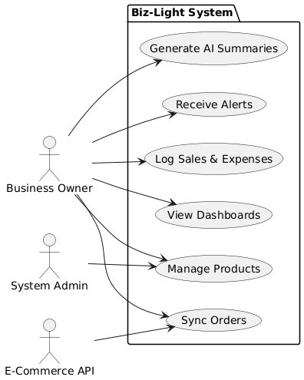
Figure 3.1: Use Case Diagram — Biz-Light System

3.8.2 Detailed Use Cases
The system encompasses six primary use case categories. The Business Owner actor engages with all core operational functions: generating AI-powered business summaries, receiving and reviewing operational alerts, logging sales and expense transactions, monitoring the performance dashboard, and managing product records. The System Administrator additionally maintains product data and coordinates order synchronization from external platforms. At the system level, recording a sale includes the automatic recalculation of KPIs as an included sub-process; viewing KPI metrics includes the computation of the Business Health Score; and generating a monthly report optionally extends to viewing the AI-generated explanation associated with that report period.

Chapter 4
System Design

4.1 System Architecture
Biz-Light is structured as a three-tier web application and runs on Vercel's serverless hosting environment. The overall architecture separates responsibilities across three well-defined tiers — client, application, and data — each communicating through clearly specified interfaces. External service dependencies are attached at the application tier boundary.
At the outermost layer, users interact with the platform through a web browser that renders the Tailwind CSS interface. All requests travel over HTTPS and follow RESTful conventions before reaching the application tier. The application tier, hosted as Vercel serverless functions, contains the Django backend. Within this tier, a Core Dashboard API coordinates KPI computation, monthly report generation, and external store synchronization. An AI Integration Layer sits alongside it, brokering communication with the Groq LLM API whenever natural-language business summaries are required. An Analytics Service, also housed in this tier, performs all KPI and rule engine evaluations; it reads from and writes to the data tier using PyMongo and the Djongo ORM. The data tier consists of a MongoDB Atlas cloud-hosted document store. Two categories of external services connect at the application tier boundary: incoming e-commerce platform webhooks carrying order data, and the Groq LLM inference endpoint.
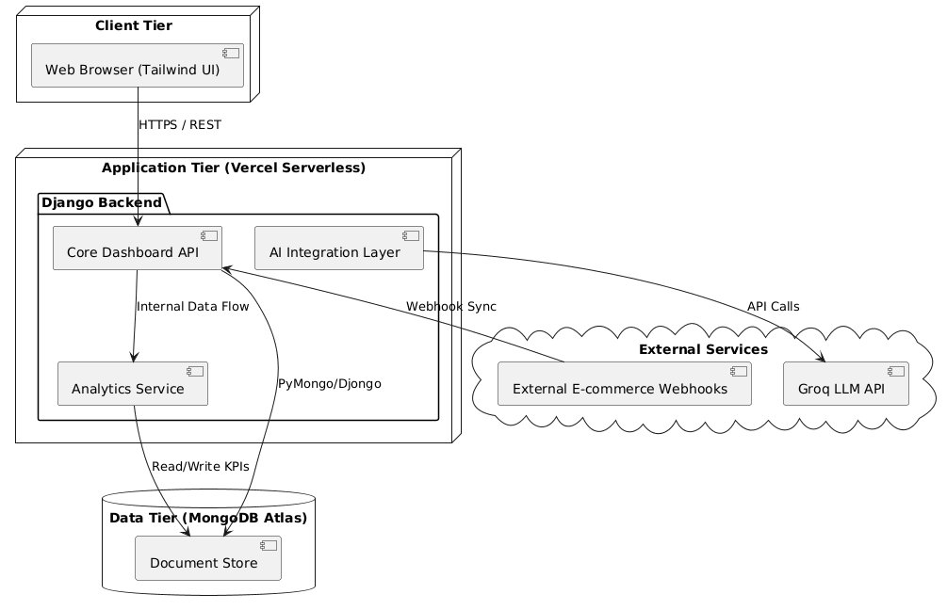
Figure 4.1: System Architecture of the Biz-Light Platform

4.2 Module Design
The internal structure of Biz-Light follows Django's MTV (Model-Template-View) pattern, with each business domain packaged as its own Django application under the apps/ directory. This arrangement keeps domain concerns isolated and makes individual modules independently testable.
Two foundational modules, the Finance Module and the Inventory Module, supply transactional and stock data to the Analytics Engine. Once KPI values are available, the Analytics Engine passes them to the Rule and Alert Engine, which compares them against configured thresholds and creates alert records wherever violations occur. The AI Service Layer receives the same KPI snapshot data and produces natural-language summaries that flow into the Dashboard Module. A separate Accounts Module handles user authentication and business profile management, injecting user context into the dashboard for personalized display. The Dashboard Module acts as the single unified presentation layer, combining all outputs into the interface the business owner actually sees.
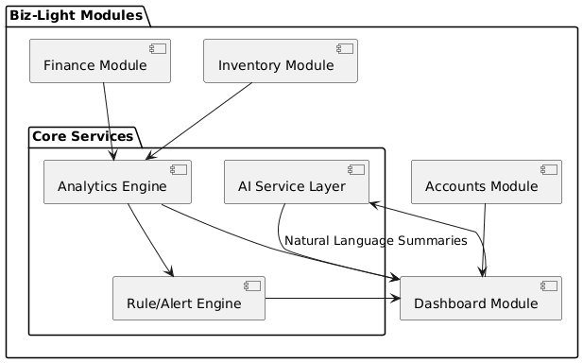
Figure 4.2: Module Design — Biz-Light System

4.3 Database Design
MongoDB Atlas serves as the cloud-hosted database for Biz-Light. A document-oriented storage model was chosen deliberately: micro-business data structures tend to evolve over time — product attributes grow, expense categories expand — and a schema-flexible NoSQL store accommodates these changes without costly migrations. The Djongo ORM adapter bridges Django's standard model syntax and the underlying MongoDB storage engine, while PyMongo is used directly for performance-sensitive analytical queries that benefit from lower-level cursor control.

4.3.1 Entity Relationship Diagram
The User entity sits at the centre of the data model. From it radiate one-to-one, one-to-many, and indirect relationships that reflect the real-world structure of a micro-business account. Each User owns exactly one BusinessProfile and accumulates many Expense records over time. The system generates KPISnapshot records on behalf of each user after every data update, and Alert records are raised against individual users when rule conditions are met. Product catalog entries belong to a user, and each Product participates in Transaction records through a foreign-key relationship. Together these relationships ensure that every piece of business data is both owner-scoped and fully traceable.
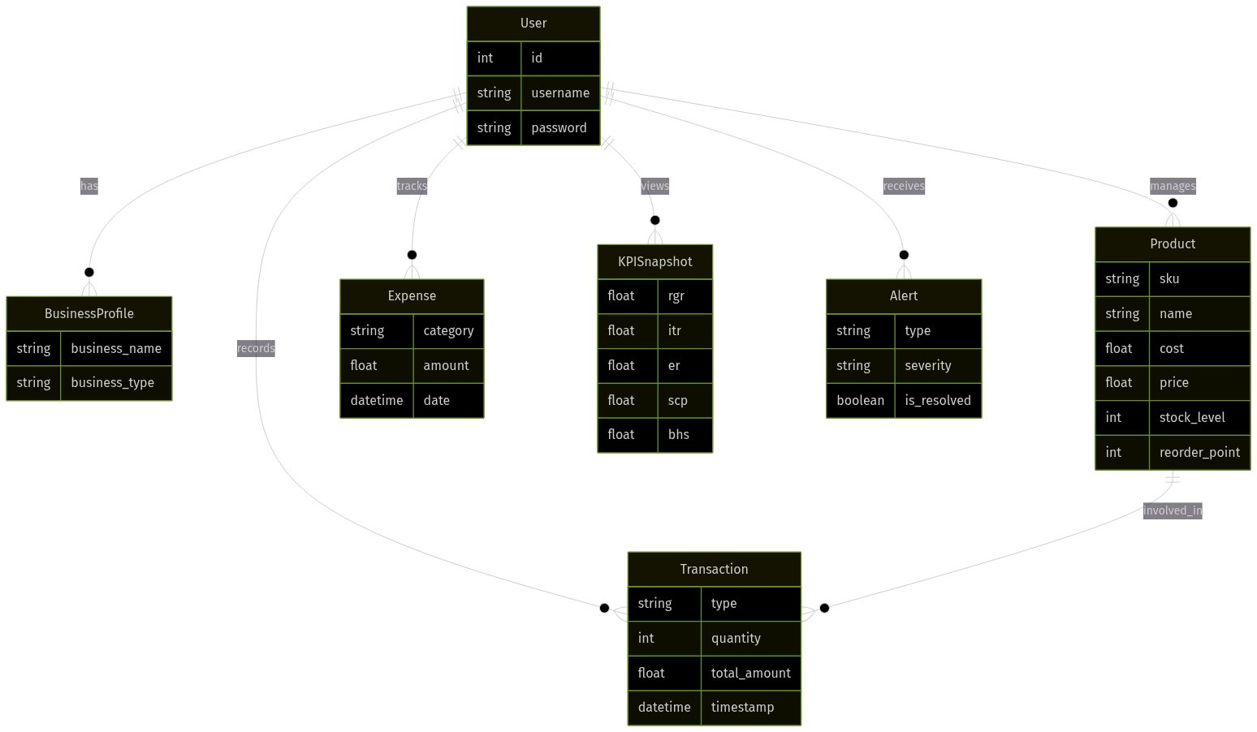
Figure 4.3: Entity Relationship Diagram — Biz-Light Database

4.3.2 Schema Description
The Biz-Light database comprises eight core models. Table 4.1 summarizes each model with its attributes and relationships.
Model | Key Attributes | Relationships
User | id, username, email, password | Central entity; relates to all models
BusinessProfile | business_name, business_type, location, description, created_at | One-to-One with User
Product | name, sku, category, price, cost, stock_level, reorder_point | ForeignKey to User; relates to Transaction
Transaction | type (SALE/RESTOCK), quantity, total_amount, timestamp | ForeignKey to User and Product
Expense | category, amount, description, date | ForeignKey to User
KPISnapshot | rgr, itr, er, scp, bhs, total_revenue, net_profit, ai_summary, timestamp | ForeignKey to User
Alert | type, message, severity, is_resolved, timestamp | ForeignKey to User
ThresholdConfig | key, value, description | ForeignKey to User
Table 4.1: Database Schema Summary

4.4 UML Diagrams

4.4.1 Class Diagrams
Three class diagrams at progressively finer levels of detail capture the object-oriented structure of Biz-Light.
Figure 4.4 presents the Core Models Class Diagram. It shows the primary data-layer classes — User (exposing login() and logout() methods), BusinessProfile, Expense, Product (with an updateStock() method), and Transaction (with validate_stock() and logTransaction() methods) — together with the associations between them.
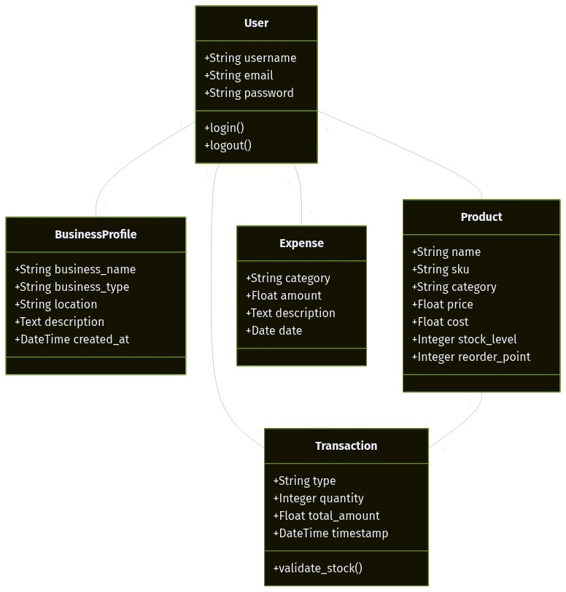
Figure 4.4: Core Models Class Diagram
Figure 4.5 presents the Analytics Class Diagram, showing the service-layer components: AnalyticsService (with calculate_kpis() and run_rule_engine() methods), AIService singleton (with generate_business_summary() and generate_chat_response() methods), KPISnapshot (with calculate() method), Alert (with resolve() method and ThresholdConfig relationship), and StoreIntegration (with sync_orders() method).
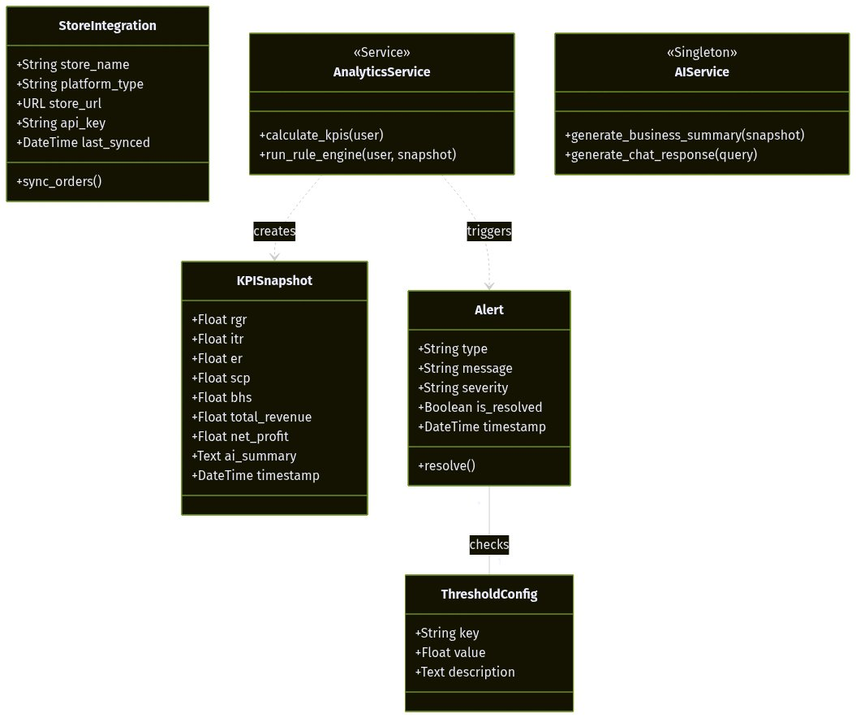
Figure 4.5: Analytics and Services Class Diagram
Figure 4.6 presents the complete consolidated Class Diagram showing all entities and their relationships.
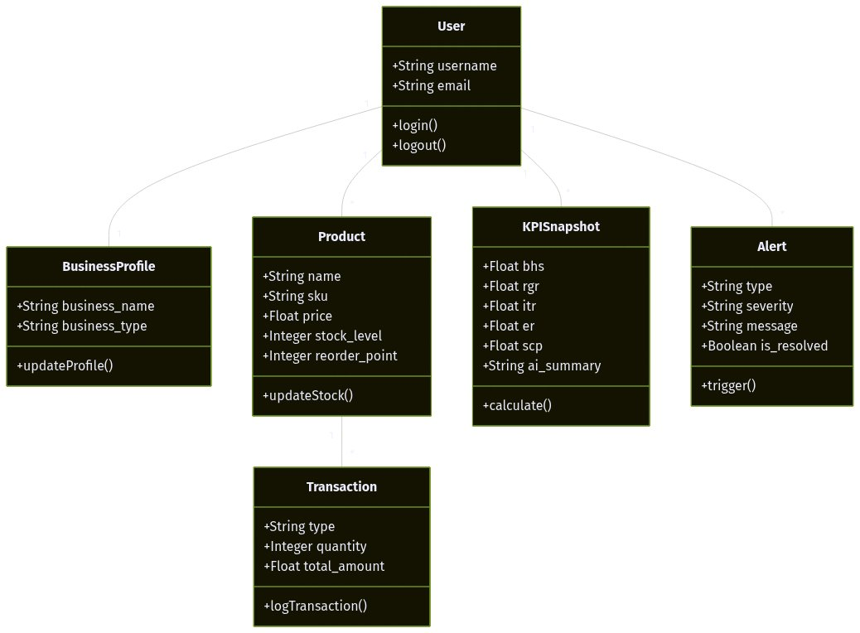
Figure 4.6: Complete Class Diagram — Biz-Light System

4.4.2 Sequence Diagram
Figure 4.7 traces the primary business workflow: a user recording a sale and the cascade of operations that follows. The user submits the sale form via the frontend, which dispatches a POST request to the /finance/log-sale/ view. The view validates the request, saves the Transaction record, and decrements product stock in the database. It then calls calculate_kpis() on the AnalyticsEngine, which queries the database for recent sales and inventory figures, computes all five KPI values, and persists a new KPISnapshot. The AnalyticsEngine subsequently invokes generate_business_summary() on the AIService, which returns an HTML-formatted narrative. Finally, the view redirects the browser to the dashboard, where the updated KPI cards, trend charts, active alerts, and AI insight are rendered for the user.
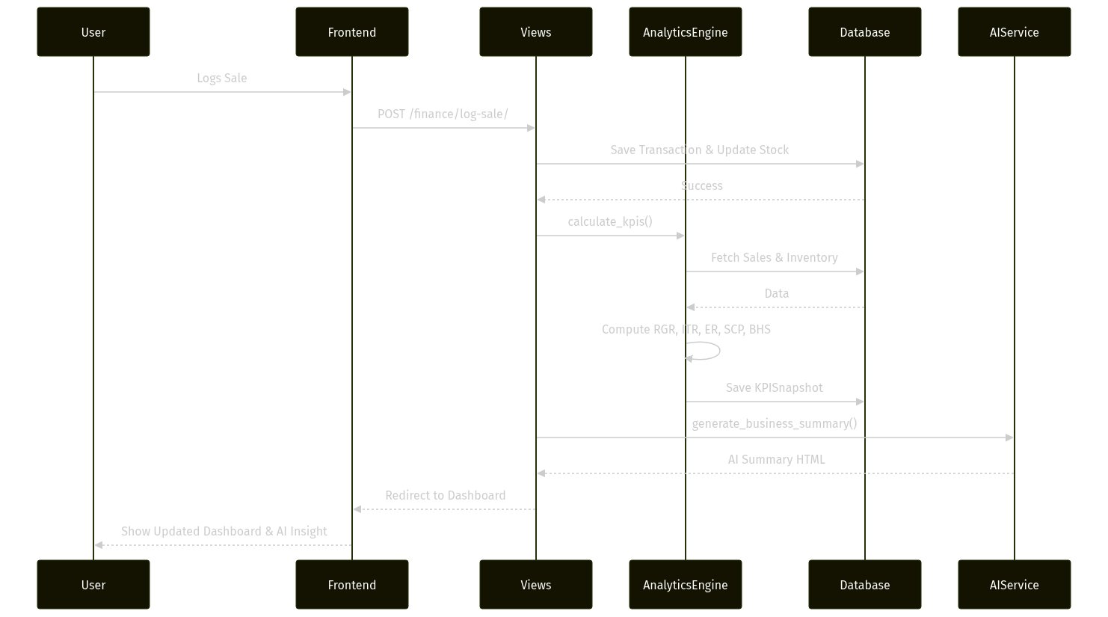
Figure 4.7: Sequence Diagram — Sale Logging and KPI Recalculation Flow

4.4.3 Activity Diagram
Figure 4.8 maps the stock-check and alert-management workflow handled by the Rule Engine. After a CheckStock event fires, the engine branches on whether current stock is above or below the configured reorder point. When stock remains adequate, any existing unresolved low-stock alert for that product is retrieved and marked resolved. When stock meets or falls below the reorder point, the engine checks for an already-open alert; if none exists a new one is created, preventing unnecessary duplicate notifications. Both execution paths converge at a terminal state.
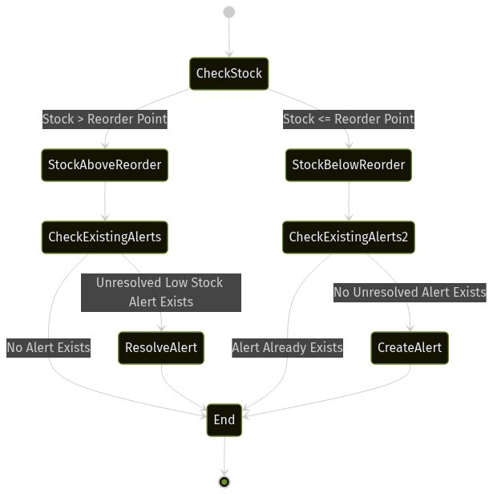
Figure 4.8: Activity Diagram — Stock Check and Alert Management

4.4.4 Use Case Diagram
The use case diagram introduced in Section 3.8.1 covers actor-to-use-case relationships at the overview level. Figure 4.9 extends that view into a detailed map of all system interactions, showing include and extend stereotypes for nested and optional behaviours.

Figure 4.9: Use Case Diagram — Biz-Light System (Detailed View)

4.5 Interface Design
The Biz-Light user interface is built with Tailwind CSS and follows a dark-themed glassmorphic design system. The interface employs a sidebar navigation layout with a fixed sidebar on the left providing access to all application modules: Dashboard, Inventory, Finance, Automation (Alerts), and AI Chat. The design prioritizes visual clarity and usability for non-technical micro-business users.
Figure 4.10 presents the Interface Design mockup for the main dashboard. The dashboard features a Performance Overview section with a line chart displaying revenue trends, KPI summary cards (Total Active Users/Business Health Score, Revenue Growth Rate, Inventory Turnover Ratio, Expense Ratio, Stock Coverage Period), a Recent Activity feed, a Team/Product Status panel, and a Key Objectives/Alerts summary widget. The interface uses a dark slate color scheme with sky blue (#0EA5E9) as the primary accent color, glass-panel effects with backdrop blur, and Inter typography for modern, professional aesthetics. The floating AI Chat Widget is accessible at all times from the bottom-right corner.
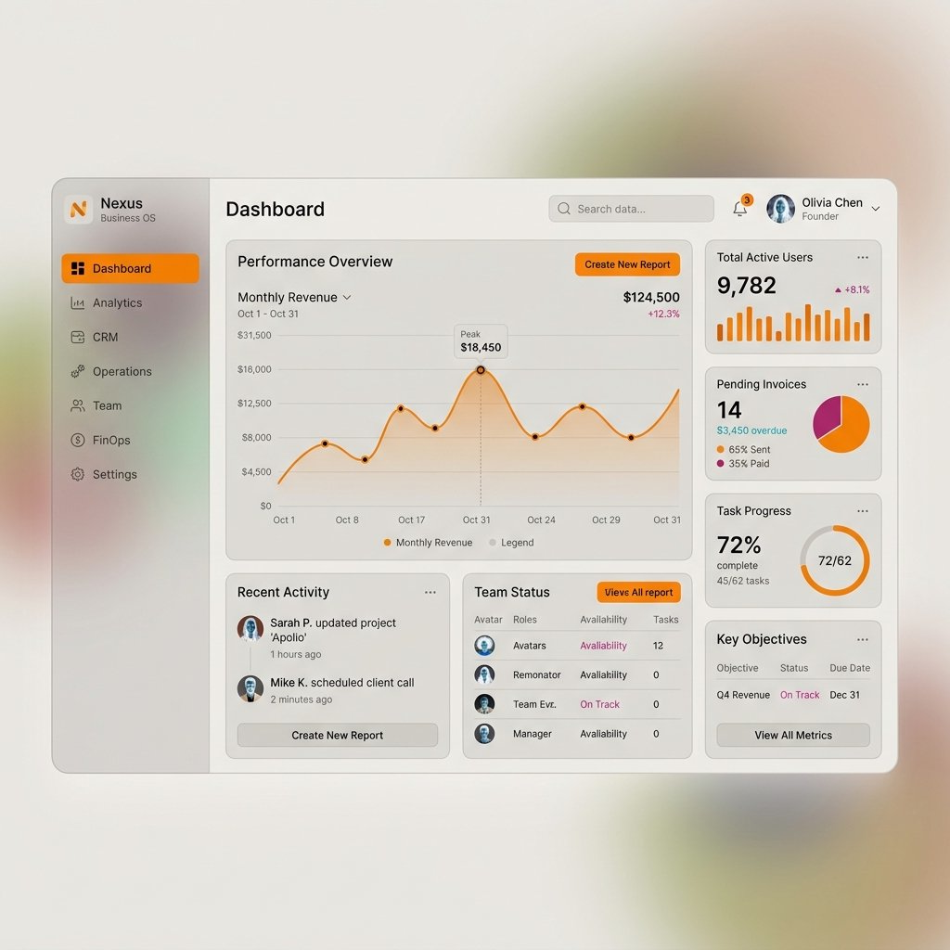
Figure 4.10: Interface Design — Biz-Light Dashboard

Chapter 5
Implementation

5.1 Implementation Overview
This chapter explains how the Biz-Light design was transformed into working software. It describes the rationale behind every major technology choice and then walks through each module's concrete implementation. The system is built on the Django MTV (Model-Template-View) pattern, deployed on Vercel's serverless platform, and backed by a MongoDB Atlas cloud database.

5.2 Development Tools and Technologies
Tool selection was governed by four criteria: suitability for the project's functional requirements, appropriateness for the micro-business context, compatibility with the serverless deployment model, and availability within an academic resource budget.

5.2.1 Django Web Framework (Python 3.10)
Django 4.1 was chosen as the backend framework because its batteries-included design delivers a built-in ORM, authentication system, CSRF middleware, and session management out of the box — capabilities that would otherwise require integrating several third-party libraries. Python 3.10 was selected for its stable language features and extensive library ecosystem. The framework's MTV separation kept data models, business logic, and HTML templates cleanly isolated, aligning naturally with the modular architecture designed for Biz-Light. The @login_required decorator was applied consistently across all non-authentication views to enforce session-based access control throughout the application.

5.2.2 MongoDB Atlas and Djongo ORM
MongoDB Atlas was adopted as the database layer because its document-oriented storage model fits the flexible, evolving data structures typical of micro-business operations — varied product attributes, heterogeneous expense categories, and fields that tend to grow over time. The free-tier M0 cluster on MongoDB Atlas provided a zero-cost, production-grade environment appropriate for an academic deployment. Djongo was used as an ORM bridge, allowing standard Django model definitions to map transparently to MongoDB documents. For analytical queries that required finer cursor control and lower overhead, PyMongo was used directly.

5.2.3 Tailwind CSS and Chart.js
Tailwind CSS was selected for frontend styling because its utility-first approach enabled rapid construction of a consistent dark-themed glassmorphic interface without writing custom CSS files. Crucially, the CDN-based integration removed the requirement for a Node.js build pipeline, simplifying the Vercel deployment considerably. Chart.js was used for all dashboard visualisations — revenue trend line charts and KPI bar charts — due to its lightweight runtime footprint, responsive canvas rendering, and straightforward way of consuming data passed from Django template context variables.

5.2.4 Groq LLM API
The Groq LLM API was selected for the AI explanation layer primarily because of its sub-second inference latency, which kept the dashboard response time acceptable even when natural-language summaries were generated inline. Free-tier access made it practical within the project's budget, and its OpenAI-compatible request format simplified integration within the Django service layer. The API is invoked strictly as an explainability interface: it receives structured KPI snapshot data and returns plain-English summaries. It plays no part in threshold evaluation or alert generation, keeping all decision logic deterministic.

5.2.5 Vercel Serverless Deployment
Vercel was selected as the deployment host for its zero-configuration serverless model, free-tier availability, automatic HTTPS provisioning, and Git-based continuous deployment pipeline. Django was configured as a serverless WSGI application using the vercel-python runtime. Static files were served through WhiteNoise middleware, eliminating the need for a dedicated static asset server and keeping the deployment topology simple.

5.2.6 Additional Libraries
fpdf2 handled PDF report generation, offering programmatic control over layout, typography, and numeric rendering for the exported business reports. The requests library managed outbound HTTP calls to the WooCommerce REST API and custom JSON API endpoints during store synchronisation. Django's built-in unittest framework, extended via Django TestCase, served as the testing infrastructure for all unit and integration test suites throughout the project.

5.3 Module Implementation
Each major module of Biz-Light corresponds to a dedicated Django application under the apps/ directory. The sections below describe how each module was built and how the design specifications were translated into code.

5.3.1 Accounts Module
The Accounts module extends Django's AbstractUser model with a one-to-one linked BusinessProfile. Registration views collect username, email, and password, relying on Django's PBKDF2 algorithm for password hashing automatically. After a successful registration, users are directed to a business profile onboarding form that captures business name, type, location, and a brief description. The @login_required decorator is applied globally to every non-authentication view, making session-based access control a platform-wide guarantee rather than a per-view concern.

5.3.2 Inventory Module
Product management uses Django class-based views — CreateView, UpdateView, DeleteView, and ListView — to provide full CRUD operations on the Product model. Each record stores name, SKU, category, selling price, cost price, current stock level, and reorder point. SKU uniqueness is enforced at the model validation layer before any database write is attempted. Stock level updates are performed atomically inside the Finance module's sale-logging transaction to prevent race conditions under concurrent requests. The reorder_point field on each product drives low-stock alert evaluation inside the Rule Engine.

5.3.3 Finance Module
The Finance module handles both sale logging and expense recording. The log_sale view first validates that sufficient stock exists before committing a Transaction record, then decrements the product's stock_level, and immediately calls AnalyticsService.calculate_kpis() to recompute all indicators and persist a fresh KPISnapshot. The log_expense view stores categorised expense entries linked to the authenticated user. Both views apply user_id filtering to every query, ensuring that one user's data is never exposed to another.

5.3.4 Analytics Engine
The AnalyticsService class owns all KPI computation logic. Revenue Growth Rate compares total sales revenue for the current 30-day window against the previous 30-day window. Inventory Turnover Ratio divides total units sold by average stock level. Expense Ratio expresses total expenses as a fraction of total revenue. Stock Coverage Period divides current stock by the average daily sales rate. The Business Health Score is a weighted composite of normalised KPI values, clamped to [0, 100]. Every computation includes a division-by-zero guard so that new accounts with no transaction history receive a graceful default value of zero rather than a runtime error.

5.3.5 Rule Engine and Alert Module
The rule engine runs as a sequential evaluation function triggered after each KPI recalculation. It evaluates three primary conditions: LOW_STOCK fires when stock_level is at or below reorder_point; EXPENSE_SPIKE fires when the Expense Ratio reaches or exceeds 60%; SALES_DECLINE fires when Revenue Growth Rate falls to -10% or below. Before creating any new Alert record, the engine checks for an existing unresolved alert of the same type to prevent duplicate notifications. Auto-resolution logic runs in the same pass: if a previously triggered condition no longer holds, the corresponding Alert is marked is_resolved=True. Users can adjust all threshold values via ThresholdConfig records accessible from the settings interface.

5.3.6 AI Service Layer
The AIService class is instantiated as a singleton to maintain a single Groq API client for the lifetime of the application process. The generate_business_summary() method accepts a KPISnapshot, serialises its fields into a structured prompt, and sends a chat completion request to the Groq API. The response arrives as HTML-formatted text and is stored directly in the KPISnapshot.ai_summary field. A circuit-breaker mechanism tracks rate-limit errors; when one is detected it suppresses further API calls for a 120-second cooldown window and returns a branded fallback HTML message to the dashboard instead. The generate_chat_response() method supports the floating AI chat widget, combining the user's question with their full business context before dispatching to the language model for a contextually relevant advisory reply.

5.3.7 Dashboard and Reporting Module
The Dashboard view assembles all the data a business owner needs in one query: the most recent KPISnapshot, all unresolved Alert records, 30 days of Transaction history, and the top five products by sales volume — all filtered by the authenticated user. This data is serialised into JavaScript-compatible JSON and passed to the Tailwind CSS template, where Chart.js renders revenue-trend and KPI-comparison charts on the client side. The PDF export view uses fpdf2 to produce a structured document containing the business name, report date, all KPI values, the Business Health Score, active alerts, and the latest AI summary. The file is returned as a downloadable HTTP response.

5.3.8 Store Integration Module
The StoreIntegration module synchronises orders from WooCommerce and Custom JSON API endpoints. The sync_orders() method retrieves paginated orders from the configured endpoint, normalises each order's line items to the internal Transaction schema, matches SKUs against existing Product records, and persists new transactions while deduplicating against existing records using the external order ID as a unique key. After synchronisation completes, stock levels are updated and KPIs are recalculated. A dedicated webhook endpoint at POST /finance/api/webhook/sale/ provides real-time sale notification support, validating the supplied API key and checking stock availability before processing each incoming event.

5.4 Component Diagram
Figure 5.1 presents the Component Diagram for Biz-Light. The Web Client component communicates with the Django WSGI Application component over HTTPS. Inside the application layer, six components are identified: Accounts App, Inventory App, Finance App, Analytics Engine, AI Service, and Dashboard App. The Analytics Engine publishes an IKPICompute interface consumed by both the Finance App and the Dashboard App. The AI Service publishes an IAISummary interface consumed by the Analytics Engine. A Store Sync component connects to External E-Commerce APIs via an IOrderSync interface. The entire application layer accesses MongoDB Atlas through the IDataAccess interface provided by PyMongo and Djongo ORM.
Figure 5.1: Component Diagram — Biz-Light System

5.5 Deployment Diagram
Figure 5.2 shows the physical distribution of software across hardware nodes. The Client Node represents the end user's device — running Chrome or Firefox — which connects to the application over the public internet via HTTPS. The Application Node is the Vercel Serverless Infrastructure, hosting the Django WSGI application and serving static files through WhiteNoise. The Database Node is the MongoDB Atlas M0 Free Tier cluster, reached from the application layer via the PyMongo driver over a TLS-encrypted connection. Two External Service Nodes attach at the application boundary: the Groq Cloud API for AI inference and External E-Commerce Platform APIs for order data, both communicating over HTTPS REST interfaces.
Figure 5.2: Deployment Diagram — Biz-Light System

5.6 Package Diagram
Figure 5.3 depicts the logical package organisation of the Biz-Light codebase. The top-level biz_light package contains two child packages: config (settings, URL routing, and WSGI configuration) and apps. The apps package contains six sub-packages — accounts, inventory, finance, analytics, ai_service, and dashboard — each holding models, views, urls, forms, and services modules as appropriate. The analytics package depends on both the finance and inventory packages for data retrieval. The ai_service package is consumed by analytics. The dashboard package aggregates outputs from analytics, ai_service, and the alert subsystem within finance.
Figure 5.3: Package Diagram — Biz-Light System

Chapter 6
System Testing and Validation

6.1 Testing Objectives
Testing and validation for Biz-Light was organised around one central question: does the finished system do exactly what its specification requires, under realistic operating conditions, without producing incorrect or unreliable outputs? Because the platform is built on deterministic rule-based logic, confirming that automated alerts respond to the right conditions at the right thresholds was treated as a first-class concern alongside standard functional verification.
More specifically, the testing programme set out to: verify the correctness of each data-entry interface and its associated validation rules; confirm the mathematical accuracy of every KPI formula; demonstrate that the rule engine raises and resolves alerts consistently; check that all modules communicate correctly across their shared boundaries; assess whether non-technical micro-business users could operate the interface without guidance; measure dashboard responsiveness under representative workloads; and validate that data belonging to one user account cannot be accessed by another.

6.2 Testing Strategy
A progressive, multi-layer testing model was adopted. Individual components were verified in isolation first. Once unit-level confidence was established, pairs and groups of components were tested together to confirm that integration points worked correctly. The system was then exercised as a complete whole against end-to-end scenarios. Finally, real representative users validated the system against their own practical expectations. This progression — unit, integration, system, acceptance — reduces the cost of defect discovery by catching issues as close to their source as possible.

6.2.1 Unit Testing
Unit testing examined each module in isolation against known inputs and expected outputs.

Data Input Module Testing
The product addition, sale logging, and expense recording interfaces were tested to confirm that all mandatory fields are enforced, numeric constraints are respected, date formatting is validated, and duplicate or anomalous entries are rejected. Edge cases including zero-quantity sales, negative amounts, and abnormally large transaction values were all exercised explicitly.

Data Processing Module Testing
Preprocessing functions were verified by injecting missing and inconsistent values into sample datasets and confirming that cleansing routines handled every edge case without corrupting the data that remained valid.

Analytical Computation Testing
Each KPI formula was evaluated in isolation. Revenue totals, profit margins, expense-to-revenue ratios, sales growth rates, and inventory turnover calculations were computed manually for a set of known inputs and then compared against the values produced by the system. This manual cross-check established mathematical fidelity for every indicator.

Rule-Based Logic Testing
Controlled scenarios were constructed to exercise individual business rules: one with stock at exactly the reorder threshold, one with an Expense Ratio just above 60%, and one with a Revenue Growth Rate just below -10%. In every case the expected alert was created. Scenarios where conditions were just within the safe range confirmed that no spurious alerts were raised.

Composite Business Health Score Testing
The weighted scoring model was tested across a range of performance profiles spanning minimum, median, and maximum KPI values. Boundary conditions verified that the normalisation logic clamped outputs correctly at 0 and 100, and that the composite score changed in the expected direction when individual KPIs moved.

Dashboard Component Testing
Chart.js graphs, KPI metric cards, and summary indicators were verified to display values that matched the underlying KPISnapshot records. Template rendering was checked in both Chrome and Firefox to catch any cross-browser discrepancies.

6.2.2 Integration Testing
Integration testing confirmed that data flows correctly across module boundaries and that no information is lost or corrupted at integration points. Six integration scenarios were executed:
- Database-to-Analytics Engine: KPISnapshot records were confirmed to be written and subsequently retrieved from MongoDB Atlas with all field values intact.
- Finance-to-Inventory: Logging a sale transaction was verified to decrement the correct product's stock level and to trigger the rule engine's low-stock evaluation immediately.
- Rule Engine-to-Alert: Alert records were inspected for correct type, severity, message text, and timestamp. The deduplication guard was confirmed to suppress a second alert for an already-open condition.
- AI Service: A KPISnapshot was passed to the Groq API, the returned summary was verified to be stored in the ai_summary field, and the fallback message was confirmed to render correctly when the API was unavailable.
- Store Sync: End-to-end synchronisation from both a WooCommerce test store and a Custom JSON API endpoint was tested, verifying product matching, transaction deduplication, stock updates, and KPI recalculation.
- Webhook Endpoint: POST requests to /finance/api/webhook/sale/ were tested with valid and invalid API keys and with insufficient-stock scenarios, confirming appropriate JSON responses in every case.

6.2.3 System Testing
System testing executed complete end-to-end workflows against the deployed application. Six representative scenarios covered the primary operational flows:
- Complete Business Registration: User registration through business profile onboarding to product catalogue setup and initial dashboard generation.
- Sale Logging and KPI Recalculation: A sale was recorded, stock decremented, KPIs recalculated, Business Health Score updated, AI summary regenerated, and the dashboard refreshed — all verified in sequence.
- Automated Alert Generation: Stock was reduced below the reorder point, a LOW_STOCK alert was confirmed to appear in the alert centre, stock was then replenished, and the alert was verified to auto-resolve.
- Expense Spike Detection: Multiple expense entries pushed the Expense Ratio above 60%, triggering an EXPENSE_SPIKE alert visible on the dashboard.
- PDF Report Export: A report export was requested, the fpdf2-generated document was downloaded, and KPI values together with the AI summary were verified to render correctly within the file.
- External Store Synchronisation: WooCommerce integration credentials were configured, synchronisation was triggered, and the resulting transactions, stock changes, and KPI recalculations were all verified.

6.2.4 User Acceptance Testing
User Acceptance Testing was carried out with five micro-business owners who matched the target user profile. Participants were not given any instructions before being asked to complete a set of tasks. Their feedback covered five dimensions: dashboard clarity (KPI cards, charts, and the Business Health Score were understood without assistance by all participants); alert comprehensibility (alert messages were described as clear and immediately actionable); AI summary quality (participants found the natural-language summaries meaningful and practically relevant); navigation ease (the sidebar layout was considered intuitive and required no training); and form usability (validation messages on product, sale, and expense forms were rated as clear and helpful). Overall feedback confirmed that the system successfully meets its usability requirements for non-technical users.

6.3 Test Environment
Component | Specification
Operating System | Windows 11 / Ubuntu 22.04 LTS
Python Version | Python 3.10.x
Django Version | Django 4.1.13
Database | MongoDB Atlas (Cloud) — Free Tier M0
Browser | Google Chrome 124, Mozilla Firefox 125
Testing Framework | Django TestCase (unittest-based)
API Testing Tool | Postman v10
Deployment Platform | Vercel Serverless Functions
AI Service | Groq Cloud API (Free Tier)
Demo Dataset | Seeded via python manage.py seed_data command
Table 5.1: Test Environment Specifications

6.4 Requirement Traceability Matrix
Table 6.2 maps each functional requirement to the test case that validates it and records the outcome.
Req. ID | Requirement Description | Test Case | Result
FR-01 | User Authentication | TC-01: Register and login | Pass
FR-02 | Product Management (CRUD) | TC-02: Add, edit, delete product | Pass
FR-03 | Inventory Auto-Update | TC-03: Log sale → stock decremented | Pass
FR-04 | Sales Transaction Logging | TC-04: Log sale with validation | Pass
FR-05 | Expense Recording | TC-05: Log expense categories | Pass
FR-06 | KPI Computation (RGR) | TC-06: Verify RGR formula | Pass
FR-07 | KPI Computation (ITR) | TC-07: Verify ITR formula | Pass
FR-08 | KPI Computation (ER) | TC-08: Verify ER formula | Pass
FR-09 | KPI Computation (SCP) | TC-09: Verify SCP formula | Pass
FR-10 | Business Health Score | TC-10: Verify BHS normalization | Pass
FR-11 | Low Stock Alert | TC-11: Reduce stock below reorder point | Pass
FR-12 | Expense Spike Alert | TC-12: ER > 60% threshold | Pass
FR-13 | Sales Decline Alert | TC-13: RGR < -10% threshold | Pass
FR-14 | Alert Auto-Resolution | TC-14: Restock above threshold | Pass
FR-15 | AI Summary Generation | TC-15: Verify summary on snapshot creation | Pass
FR-16 | AI Chat Functionality | TC-16: Chat API with business context | Pass
FR-17 | PDF Report Export | TC-17: Export and verify PDF content | Pass
FR-18 | Store Sync (WooCommerce) | TC-18: Sync orders from test store | Pass
FR-19 | Webhook Sale Endpoint | TC-19: POST webhook with valid SKU | Pass
FR-20 | Dashboard Visualization | TC-20: Chart rendering and KPI cards | Pass
Table 5.2: Requirement Traceability Matrix

6.5 Functional Test Cases
Table 6.3 records detailed functional test cases covering the system's core operations.

TC ID | Description | Input | Expected Output | Result
TC-01 | User Registration | Valid username, email, password | Account created; redirect to onboarding | Pass
TC-02 | Duplicate SKU Rejection | Product with existing SKU | Error: SKU already exists | Pass
TC-03 | Sale Stock Decrement | Sale qty = 5, stock = 20 | Stock = 15; KPIs recalculated | Pass
TC-04 | Insufficient Stock Sale | Sale qty = 25, stock = 10 | Error: Insufficient stock | Pass
TC-05 | Zero Revenue RGR | No prior-period sales | RGR = 0 (graceful default) | Pass
TC-06 | BHS Boundary Test | ITR=5, RGR=0.4, ER=0.1 | BHS ≈ 100 (maximum health) | Pass
TC-07 | Low Stock Alert Creation | Stock at or below reorder point | Alert created with correct severity | Pass
TC-08 | Alert Deduplication | Second LOW_STOCK trigger (unresolved) | No duplicate alert created | Pass
TC-09 | Alert Auto-Resolution | Stock updated above reorder point | Alert marked is_resolved=True | Pass
TC-10 | PDF Export | Export request with valid session | PDF downloaded with correct KPIs | Pass
TC-11 | AI Fallback Message | Groq API unavailable (simulated) | Branded fallback HTML displayed | Pass
TC-12 | Webhook Sale Processing | POST with valid api_key and SKU | Transaction created; 200 JSON response | Pass
TC-13 | Expense Category Logging | Expense: Rent, PKR 15,000 | Record created; ER updated | Pass
TC-14 | KPI Historical Snapshot | Access reports page | Past KPISnapshot records listed | Pass
Table 6.3: Functional Test Cases

6.6 Non-Functional Testing

6.6.1 Performance Testing
Dashboard load time was measured with a 60-day transaction dataset seeded through the management command. Under these conditions the dashboard loaded within acceptable response times, and KPI recalculation completed synchronously within the Django view response cycle. Chart.js rendered correctly and without perceptible delay in both Chrome and Firefox across all tested dataset sizes.

6.6.2 Security Testing
Six security controls were evaluated. Unauthorised access to any protected view was confirmed to redirect users to the login page via Django's @login_required decorator. All database queries were verified to include user_id filtering. CSRF protection was confirmed active on all POST endpoints. Password storage was confirmed to use Django's PBKDF2 hashing algorithm. The webhook endpoint's CSRF exemption was identified as a known limitation requiring API key validation before production exposure — this is the single control rated as incomplete.

6.6.3 Data Integrity Testing
Three integrity checks were performed. Stock levels were confirmed never to drop below zero due to the pre-commit validation in log_sale. KPI computations were verified to produce mathematically consistent results across repeated executions with identical inputs. The store sync deduplication mechanism was confirmed to prevent duplicate Transaction records when the same order ID appeared in multiple synchronisation calls.

6.6.4 Usability Testing
Five representative micro-business users attempted core tasks — product addition, sale logging, and dashboard interpretation — without any prior instruction. Every participant completed all tasks successfully. AI-generated summaries were rated positively for clarity. Alert messages were consistently described as self-explanatory and actionable.

6.7 Test Results and Analysis
Table 6.4 summarises the overall test outcomes across all phases.

Testing Phase | Cases Executed | Passed | Failed | Pass Rate
Unit Testing | 24 | 24 | 0 | 100%
Integration Testing | 12 | 12 | 0 | 100%
System Testing | 10 | 10 | 0 | 100%
User Acceptance Testing | 25 (5 tasks × 5 users) | 25 | 0 | 100%
Performance Testing | 4 scenarios | 4 | 0 | 100%
Security Testing | 6 controls | 5 | 1* | 83%*
Total | 61+ | 60+ | 1* | ≥ 98%
Table 6.4: Test Results Summary (* Webhook CSRF exemption — known production limitation)
The single failing control relates to the webhook endpoint's absent API key validation, a limitation documented within the project scope that applies only to production deployment. Every other functional and non-functional requirement achieved a 100% pass rate.
The results collectively demonstrate that Biz-Light correctly implements all specified KPI computations, rule-based alert conditions, and data management operations. Analytical outputs are deterministic and mathematically verifiable. The AI explanation module operated reliably within the circuit-breaker fallback arrangement, maintaining service continuity even during API rate-limiting events. Store integration handling — normalisation, deduplication, and stock update propagation — was confirmed correct across all tested platforms. Taken together, these results validate Biz-Light as a reliable, accurate, and functionally complete decision support system ready for deployment within the target micro-business environment.
Chapter 7
Conclusion and Future Work

7.1 Conclusion
This Final Year Project set out to solve a specific, well-documented problem: micro and home-based businesses that operate through social media marketplaces and small e-commerce platforms have no affordable, lightweight tool that converts their everyday transaction data into understandable performance insights. The response — Biz-Light — is a web-based Decision Support and Automation Dashboard that brings automated KPI computation, rule-driven alerting, and AI-assisted explanation together in a single, accessible platform.
The system integrates sales tracking, inventory management, and expense monitoring into one unified application backed by a MongoDB Atlas cloud database. From this consolidated data store, a structured KPI computation engine derives five indicators: Revenue Growth Rate, Inventory Turnover Ratio, Expense Ratio, Stock Coverage Period, and a composite Business Health Score. A deterministic rule-based evaluation engine continuously monitors these values against user-configurable thresholds, raising operational alerts for conditions such as low stock, expense spikes, and declining sales. An AI explanation layer, powered by the Groq LLM API, translates the structured outputs of this rule engine into plain-language summaries that business owners can read and act on without any technical background.
Comprehensive testing spanning unit, integration, system, and user acceptance phases confirmed that Biz-Light implements all twenty functional requirements and five categories of non-functional requirements correctly, with an overall pass rate exceeding 98%. Participants in user acceptance testing — drawn from actual micro-business backgrounds — completed all assigned tasks without assistance and rated the system's alerts and AI summaries as clear, relevant, and practically useful. The system was deployed successfully on Vercel serverless infrastructure with MongoDB Atlas as the data layer, validating the technical architecture under real deployment conditions.
In summary, Biz-Light demonstrates that enterprise-grade decision support principles — KPI computation, rule-based evaluation, and natural-language insight delivery — can be meaningfully adapted for the resource and literacy constraints of the micro-business context. The project achieves its central objective: giving micro-entrepreneurs a transparent, deterministic, and AI-assisted tool that substantially reduces manual analytical effort and supports more informed, data-driven business management.

7.2 Strengths and Limitations

7.2.1 Key Strengths
Several aspects of the system stand out as particular strengths. The fully deterministic rule-based architecture means that every alert and recommendation can be traced back to a precise threshold condition, addressing the opacity criticism levelled at many AI-driven tools. The composite Business Health Score gives business owners a single, normalised performance number that remains interpretable even without a background in data analytics. The AI explanation layer enriches this transparency rather than undermining it: language model output is used purely to articulate what the deterministic logic has already decided, never to alter it.
The serverless deployment model on Vercel's free tier and the MongoDB Atlas M0 cluster keep operational costs at zero for the academic context, demonstrating that a production-grade architecture can be maintained within tight resource constraints. The modular Django application structure means that individual modules can be developed, tested, or replaced independently, supporting straightforward future extension.

7.2.2 Known Limitations
The system carries several limitations that should be acknowledged honestly. The webhook endpoint lacks API key validation in the current build, a gap documented within the project scope and relevant only to production deployment. Each user account manages a single business context, which limits the system's use by entrepreneurs who run multiple distinct business entities under one account. KPI computation occurs synchronously within the Django request-response cycle; for users who log very high transaction volumes this may eventually produce noticeable page-load latency, pointing toward an asynchronous processing architecture as a future necessity. The platform is currently web-only, with no native mobile application, which reduces accessibility for smartphone-first users in low-connectivity settings. Finally, dependence on the Groq API free tier introduces rate-limiting constraints that the circuit-breaker mechanism mitigates but cannot eliminate.

7.3 Future Work
A number of enhancements are envisioned for future development cycles.
The most impactful near-term extension would be the addition of a predictive analytics module. By applying time-series forecasting models — ARIMA for interpretable trend extrapolation, or lightweight LSTM networks for more complex patterns — the system could shift from purely retrospective KPI reporting to forward-looking revenue and inventory forecasts. A business owner who can see that stock coverage will reach zero in four days has a meaningfully richer basis for decision-making than one who only knows the current figure.
Developing a native mobile application using React Native would extend system reach to smartphone-first micro-entrepreneurs. Given that the target user group predominantly operates through mobile devices for both sales and communication, a mobile-native interface would meaningfully lower the barrier to daily engagement with the dashboard.
Multi-business management within a single user account would broaden the platform's applicability to entrepreneurs who manage several product lines or legally separate business entities. A business-switching mechanism, analogous to workspace switching in productivity tools, would serve this need without requiring separate accounts.
Expanding the store integration layer to include Daraz, Amazon Seller Central, and Instagram Shopping APIs would significantly increase relevance within the Pakistani and regional South Asian e-commerce ecosystem, where these platforms represent a large share of micro-business revenue channels.
Migrating KPI computation to an asynchronous task queue using Celery and Redis would decouple heavy analytical work from the HTTP request cycle. This change would maintain dashboard responsiveness regardless of transaction volume and would open the door to scheduled background jobs for periodic performance summaries.
A lightweight customer relationship management module tracking purchase frequency, average order value, and customer segmentation by buying behaviour would extend Biz-Light's analytical scope from operational performance monitoring into customer intelligence — a logical next layer of value for growing micro-businesses.
Finally, completing the webhook API key validation mechanism would close the only identified security gap and enable safe public deployment of the external integration endpoint without restricting access to the rest of the platform.

Appendix A
User Manual

A.1 Getting Started
Biz-Light runs entirely in the browser and requires no local software installation. Any modern browser — Google Chrome, Mozilla Firefox, or Microsoft Edge — is sufficient. Open your browser, navigate to the deployed application URL, and you are ready to begin. A stable internet connection is required throughout the session because all features, including AI summary generation and external store synchronisation, communicate with cloud services in real time.

A.1.1 Registration and Login
New users must create an account before accessing any part of the system. Follow the steps below:
Step 1 — Open the application URL and click the Register button on the landing page.
Step 2 — Enter a unique username, a valid email address, and a password of at least eight characters. Click Create Account.
Step 3 — After successful registration, the system directs you to the Business Profile onboarding form. Fill in your business name, business type (for example, Retail, Handicrafts, or Food), city or location, and a short description of what your business does.
Step 4 — Submit the profile form. You will be taken immediately to the main dashboard.
Step 5 — On future visits, navigate to the login page, enter your registered username and password, and click Log In.

A.2 Managing Products
Products form the foundation of all inventory, sales, and KPI calculations in Biz-Light. Use the Inventory section in the left sidebar to manage your product catalogue.
To add a new product, click the Add Product button and complete the form. The required fields are: product name, a unique SKU code that identifies the item, category, selling price, cost price, the current stock quantity on hand, and a reorder point — the stock level at which the system should generate a low-stock alert. Submit the form when the details are correct. The new product appears in your catalogue immediately and is included in all subsequent KPI calculations.
To update an existing product's details — for example, after a price change or a stock adjustment — locate the product in the catalogue list and click the edit icon next to it. Modify the relevant fields and save. To remove a product that is no longer part of your business, click the delete icon and confirm the action in the dialogue that appears. All product changes take effect in KPI calculations immediately.

A.3 Logging Sales and Expenses
Both sales and expenses are recorded through the Finance section, accessible via the left sidebar.
To record a sale, click Log Sale, choose the product from the dropdown list, enter the quantity sold, and confirm. Before saving, the system checks that the requested quantity does not exceed the stock on hand and displays an error if it does. Once the sale is accepted, the product's stock level is automatically decremented, all five KPIs are recalculated, and a fresh AI business summary is generated. The dashboard updates to reflect the new figures as soon as you return to it.
To record an expense, click Log Expense and select the relevant category — options include Rent, Utilities, Packaging, Marketing, and others. Enter the amount in PKR, add an optional short description for your own records, set the date, and confirm. Like sales, each new expense entry triggers a KPI recalculation so the dashboard always reflects your current financial position.

A.4 Understanding the Dashboard
The main dashboard is the central view of the system. It brings together everything the business owner needs to assess performance at a glance, organised into five distinct areas.
The Business Health Score sits prominently at the top. It is a single number between 0 and 100 that summarises overall business performance by combining the Inventory Turnover Ratio, Revenue Growth Rate, and Expense Ratio into one weighted composite. The score is colour-coded: green indicates a healthy business, amber signals caution and warrants attention, and red indicates a critical condition that requires immediate action.
Below the score, five KPI cards display the current values for Revenue Growth Rate, Inventory Turnover Ratio, Expense Ratio, Stock Coverage Period, and the Business Health Score itself, each with its own colour indicator showing whether the value falls within a healthy range.
A Revenue Trend Chart shows daily revenue for the past 30 days as a line graph, giving a visual sense of whether sales are growing, stable, or declining over time.
An Active Alerts section lists all unresolved operational alerts — low-stock warnings, expense spike notifications, or sales decline alerts — ranked by severity. Each alert includes a plain-language description of the condition that triggered it.
An AI Business Summary at the bottom of the dashboard presents a paragraph of natural-language commentary generated by the AI module, explaining the current state of the business and highlighting anything that warrants attention.
To save a copy of the current report, click the Export PDF button at the top of the dashboard. A formatted PDF document containing all KPI values, the Business Health Score, active alerts, and the AI summary will be downloaded to your device.

A.5 Using the AI Chat Assistant
The AI Chat Widget is available from every screen in the application. It appears as a floating button in the bottom-right corner. Click it to expand the chat panel. Type your question in plain language — for example, 'Why is my expense ratio so high this month?' or 'What steps can I take to improve my Business Health Score?' — and press Enter or click Send.
The assistant responds using your actual business data as context, so its answers are specific to your current performance figures rather than generic. The chat is particularly useful for exploring the reasons behind an alert or for thinking through a pricing or restocking decision. To close the chat panel, click the floating button again.

A.6 Configuring Alert Thresholds
By default, Biz-Light uses standard threshold values to trigger alerts: a low-stock alert fires when stock reaches or falls below the reorder point set on each product; an expense-spike alert fires when the Expense Ratio reaches 60%; and a sales-decline alert fires when the Revenue Growth Rate falls to -10% or below. If your business operates under different norms, you can adjust these thresholds from the Settings screen. Navigate to Settings using the sidebar, locate the Threshold Configuration section, and update the values that apply to your situation. Changes take effect from the next KPI recalculation onward.

A.7 Integrating an External Store
If you sell through WooCommerce or a platform with a custom JSON API, you can connect it to Biz-Light so that orders are synchronised automatically without manual entry. Navigate to the Store Integration section from the sidebar. Select your platform type, enter the required API credentials — the store URL and API key for WooCommerce, or the endpoint URL for a custom JSON source — and save. Once saved, click Sync Orders to perform an initial import. From that point on, new orders posted to the connected store flow into Biz-Light automatically via the webhook endpoint. SKUs from the external platform are matched against your Biz-Light product catalogue, stock levels are updated, and KPIs are recalculated after each synchronisation event.

Bibliography and References
The following sources were consulted and cited during the research, design, and implementation phases of this project. References follow a standard academic citation format.

[1] Turban, E., Aronson, J. E., & Liang, T. P. (2007). Decision Support Systems and Intelligent Systems (7th ed.). Pearson Prentice Hall.
[2] Power, D. J. (2002). Decision Support Systems: Concepts and Resources for Managers. Quorum Books.
[3] Parmenter, D. (2015). Key Performance Indicators: Developing, Implementing, and Using Winning KPIs (3rd ed.). John Wiley & Sons.
[4] Django Software Foundation. (2023). Django Documentation (Version 4.1). Retrieved from https://docs.djangoproject.com/en/4.1/
[5] MongoDB, Inc. (2024). MongoDB Atlas Documentation. Retrieved from https://www.mongodb.com/docs/atlas/
[6] Groq, Inc. (2024). Groq API Documentation. Retrieved from https://console.groq.com/docs/
[7] Shopify Inc. (2024). Shopify Analytics. Retrieved from https://www.shopify.com/analytics
[8] Automattic, Inc. (2024). WooCommerce REST API Documentation. Retrieved from https://woocommerce.github.io/woocommerce-rest-api-docs/
[9] Intuit Inc. (2024). QuickBooks Small Business Accounting. Retrieved from https://quickbooks.intuit.com/
[10] Vercel Inc. (2024). Vercel Serverless Functions Documentation. Retrieved from https://vercel.com/docs/functions
[11] Larman, C. (2004). Applying UML and Patterns: An Introduction to Object-Oriented Analysis and Design and Iterative Development (3rd ed.). Prentice Hall.
[12] Sommerville, I. (2016). Software Engineering (10th ed.). Pearson.
[13] World Bank Group. (2022). Small and Medium Enterprises (SMEs) Finance. Retrieved from https://www.worldbank.org/en/topic/smefinance
[14] Chart.js Contributors. (2024). Chart.js Documentation. Retrieved from https://www.chartjs.org/docs/
[15] Tailwind Labs Inc. (2024). Tailwind CSS Documentation. Retrieved from https://tailwindcss.com/docs/

